

SKATURION:

Level Design

Document

Timo Bron - 170388  
Team 4 eSports

## Introduction

This document will describe the design and plan for the first level of our high-velocity aerial eSports ball game “*Skaturion”*. This document should provide all the important information about this arena, describing the goal, guidelines, and high level plan.

## Table of Contents

**General Level Design** **3**

Elevator Pitch 3

Level Design Pipeline 3

Level Design Pillars 4

Conditions of Satisfaction 5

Macro Chart 6

Theme & Setting 7

**Level: Main** **9**

Gameplay Guidelines 9

Iterations & Process Details 11

# General Level Design

## Elevator Pitch

*Skaturion* is a competitive 3 versus 3 class-based ball sports game, inspired by rugby and handball, where players move around an arena with aerial, fast-paced, ski-like movement while trying to score goals, with each pass to a teammate multiplying their score.

## Level Design Pipeline

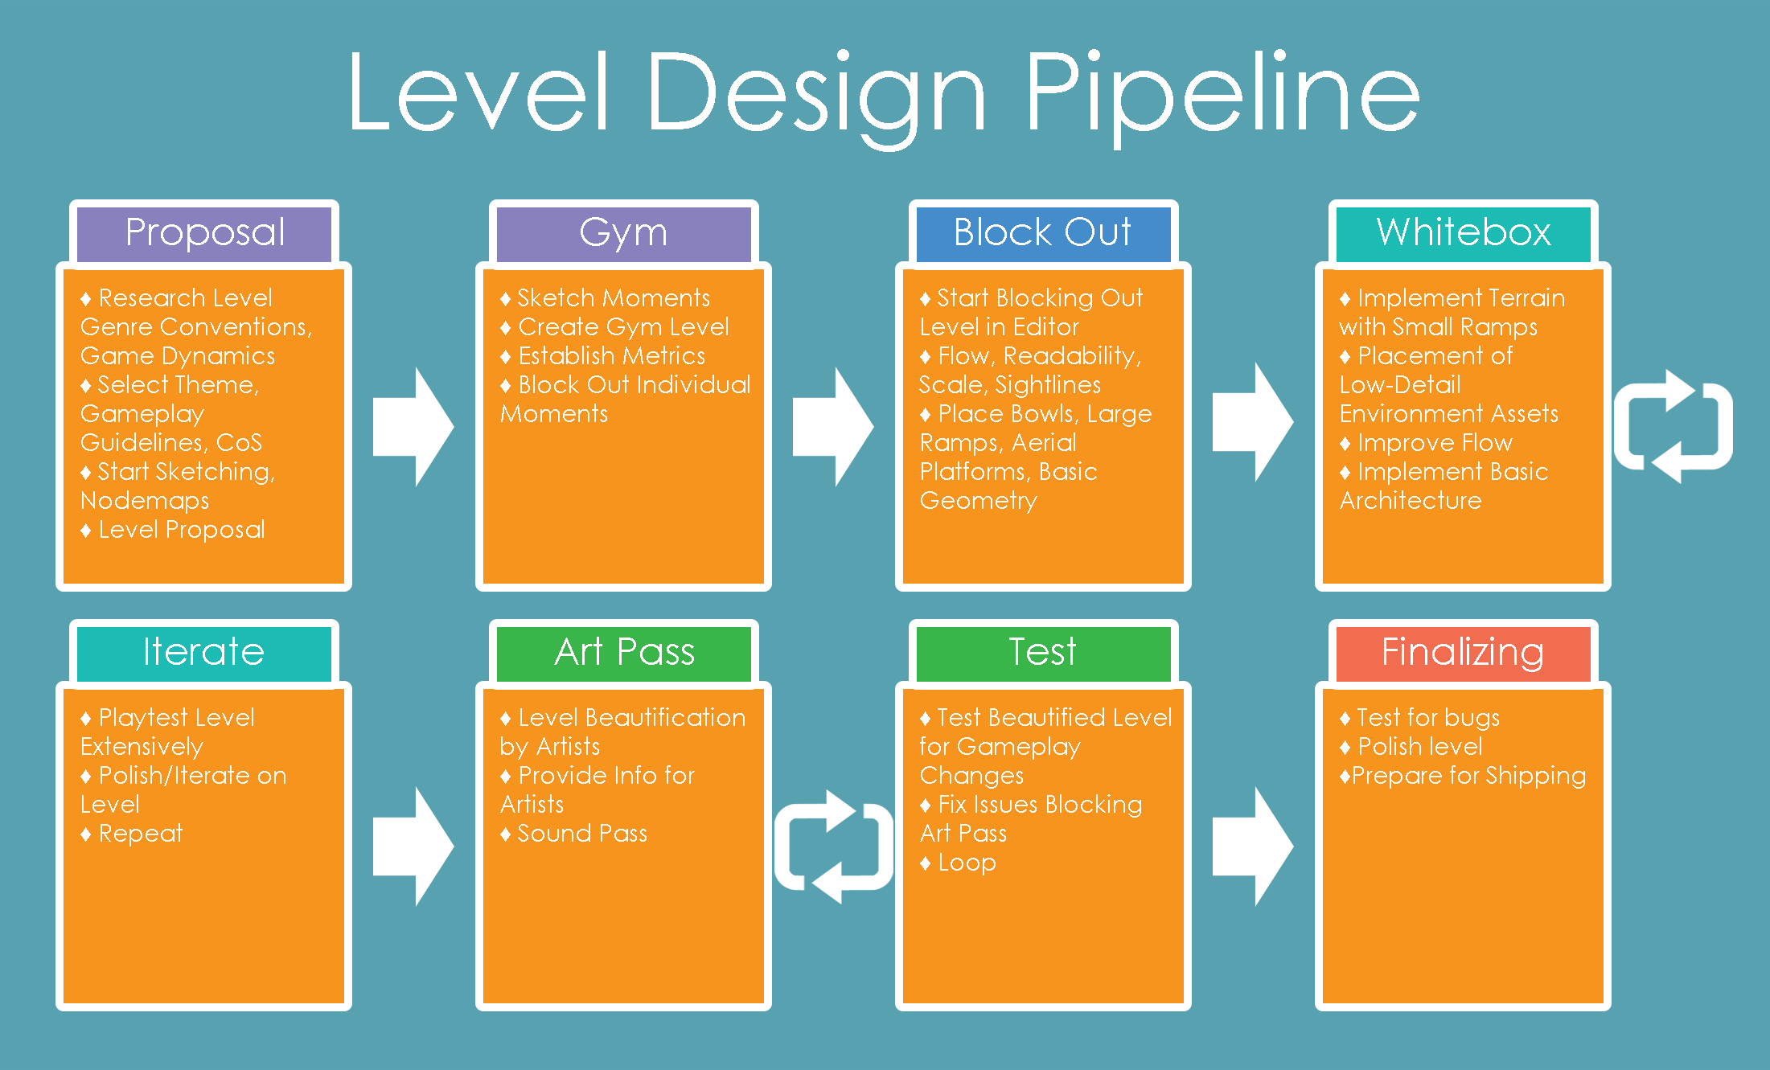

*If you find this image hard to read,* [*click here*](https://drive.google.com/a/ade-nhtv.nl/file/d/1piDiktCCTL8xVX_yST5-OdB50eqyiLdd/view?usp=sharing) *to view it full-size.*

## Level Design Pillars

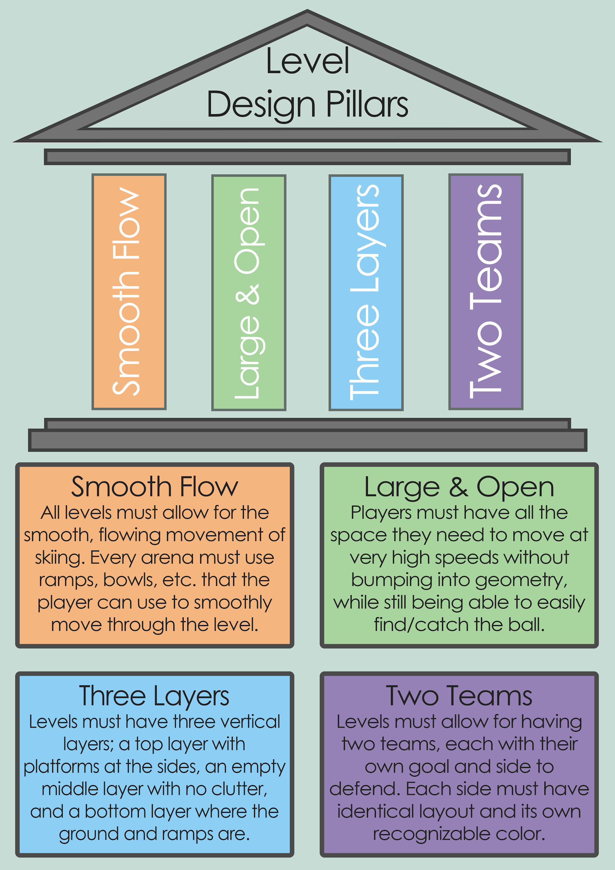

## Conditions of Satisfaction

|  |  |  |  |  |
| --- | --- | --- | --- | --- |
| **Topic** | **First Block Out** | **First Version Whitebox** | **First Iteration** | **Final Whitebox** |
| Layout | Geometry placed in right position according to (layout) sketches. | Solved major flow issues. Identify flow and navigation issues. Semi-final scale. | Scale locked down. Lock down position of ground geometry. | Final geometry. Flow and navigation final. Bugs, glitches, issues all patched. |
| Geometry | Primary ground geometry placed (bowls, ramps, etc). | Placed secondary geometry (platforms, smaller ramps). Iterated on geometry. | Most important ground geometry locked down. Iterated on secondary geometry. | All geometry locked down. |
| Lighting | Simple lighting, non-decorative. | Placed detail lighting. Lighting values set. First attempt at atmosphere. | Iterated on detail lighting. Lighting values locked down. Iterated on colors and atmosphere. | All lighting locked down. Color and atmosphere final. Ready for artists to refine. |
| Textures | Whitebox. | Whitebox with important elements highlighted. | More detailed materials, implement color scheme. | Color scheme final. Iterated on detailed materials. Ready for art pass. |
| Architecture | None. | Focal point and big landmarks architecturally recognizable. | Most prominent geometry architecturally recognizable. Focal point and big landmarks detailed architecture. | All geometry architecturally recognizable. Important geometry, focal point, and big landmarks detailed architecture. |
| Decorative Assets | None. | Whiteboxed arena environment. Recognizable landmarks/focal point. | More detailed arena environment, landmarks/focal point. | Architecturally recognizable arena. More detail assets/minor decoration. |
| Spawn Points | Existing. | Placement refined for 3v3. | Properly balanced, locked down. | Locked down. |

## Macro Chart

|  |  |  |  |  |  |
| --- | --- | --- | --- | --- | --- |
| **Arena** | **Shipped with Base Game** | **Difficulty Level** | **Size** | **Shape** | **Gameplay Focus** |
| Main Arena #1 | Yes. | Beginner to Intermediate. | Medium. | Long, regularly shaped field; limited verticality. | Onboarding new players while still providing a fun experience for intermediate players. |
| Post-Release Update: Main Arena #2 | Yes; post-release. | Intermediate. | Medium-Large. | More complex than Main; different explicit routes. | Allowing for more advanced strategies for experienced players. |
| Post-Release Update: Main Arena #3 | Yes; post-release. | Hard. | Small-Medium. | Scaled down regular field with more verticality. | Testing players’ control of movement and knowledge of game; fast-paced gameplay. |
| Free DLC Level #1 | No; acquired seperately. | Intermediate. | Large. | Clear, seperated paths; MOBA-like. | Offering new play style and variety for experienced players. |
| Free DLC Level #2 | No; acquired seperately. | Beginner to Intermediate. | Medium. | Regularly shaped. | Featuring potential new game features introduced in update/DLC. |

## Theme & Setting

1. Summary

A setting based in Ancient Rome, but with a futuristic twist, in the years after what was supposed to be the fall of the Roman Empire. It’s as if a technological revolution has happened in the Rome. It has the same classical Roman architecture, but buildings look cleaner and verticality is more emphasized.

Colors are flat and consistent; they look similar to the brick, concrete and marble often found in real Roman architecture; some building elements do also feature shiny metals, however. The arenas are similar to the Colosseum, but with high tech elements like a bubble shield, neon streaks of light, big scoreboards, etc., but also with banners of brightly colored cloth, representing the crowd’s favorite teams.

The world feels like a bright future, showing how this alternate-history Roman Empire has flourished and grown into a joyful, secure society. The sport they play and watch is a friendly competition that brings everyone together.

2. Application in World

1. *Geometry & Architecture*

The architecture style is very similar to real Ancient Roman architecture. It is based on the same principles and core elements, but they are simplified and made to look modern and clean. For example, the recognizable marble pillars don’t have really have a structural function, but are used more for decoration. They are less prominent, made thinner and straighter, and are used against walls as a way of breaking up monotony and offer more depth to an otherwise bland wall, even if the pillars only come forward just a tiny bit.

If a term had to be connected to the architectural style, it would be minimalistic neoclassicism; a modern take on the classical architecture, but stripped down. However, big recognizable structure, such as the Colosseum or a triumph arch, can have the same architecture as its real life equivalent to make sure players recognize the building. It is advised to give add futuristic elements to it however, by for example adding lights, screens, banners, etc. to somehow tie it back to the setting of the game.

1. *Colors & Materials*

Readability is key, and should have the highest priority when applying theme to an arena. It is crucial that the level is color-coded correctly and consistently. When the level is sent for an art pass, it is crucial that this readability remains intact and that it will always keep priority over theme application

To reduce visual clutter, it is advised to use flat, clean materials. Using materials such as marble, concrete, or clean stone would also maintain the intended theme. These materials should be used on most of the arena’s geometry, with potential exceptions for large structures, focal points, and buildings outside of the level.

Guidelines for readability and color-coding:

1. The arena should be divided into two color regions, blue and red, each corresponding with the color of the team assigned to that side of the arena.
2. The color and material of ramps should be distinct from the floor of the arena. There should be a red/blue line at both the bottom and top of the ramp to signify where it begins and ends.
3. Flat, horizontal surfaces should have a consistent color and material.
4. Flat vertical surfaces that could potentially block the player should be explicitly and consistently marked with a recognizable color, as to warn the player that this surface will stop their flow if they bump into it.
5. Goals should appear bright and recognizable from across the level, with the inside of the goal having the team’s primary color.
6. *Lighting*

The ideal lighting for an arena is natural daylight, however exceptions can be made as long as the curvature of ramps are easily readable, and shadows do not impact the player’s ability to see. Night scenes are fine, although the level would need additional lights to compensate for the lack of sunlight. Colored lighting should not interfere with the color-coded geometry, and is preferably avoided altogether.

3. Reference Images

This is the Colosseo Quadrato (Square Colosseum), a piece of fascist architecture using the neoclassicism style. It uses recognizable Roman architecture elements, specifically from the Colosseum, but looks more modern because of the square shape and the clean surfaces with no decorations. While we don’t want buildings to be this square and flat, as it gives a negative feeling, we can take example from this on how we can apply a modern twist to recognizable Roman architecture.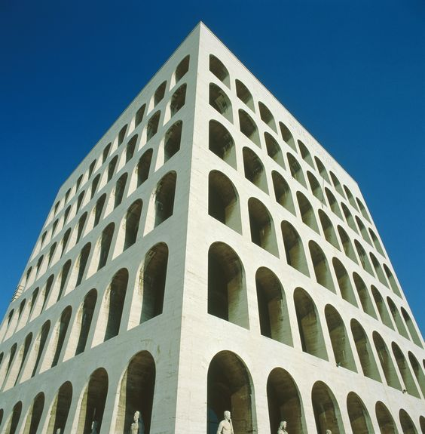

More so than in classical architecture, neoclassicism, particularly fascist neoclassicism, uses sharp corners and rectangular shapes. While it does make it look more geometrical and clean, one must watch out not to make it as cold or intimidating; we don’t want to have actual fascist architecture in our game.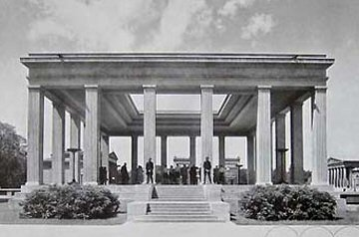

Buildings should express the tone and feel of the theme; an alternate history where the Roman Empire is a thriving civilization that has evolved beyond what it actually should have been. This also implies great construction evolution, where buildings have increased in height and size. The massing has also become bigger as buildings use pillars less for practical function and more for decoration. This image also may remind one of art deco, which can also be used as inspiration on how to decorate a building to make it look richer and more imposing. A balance must be found between making a building look clean and decorated, while preserving classical architecture elements.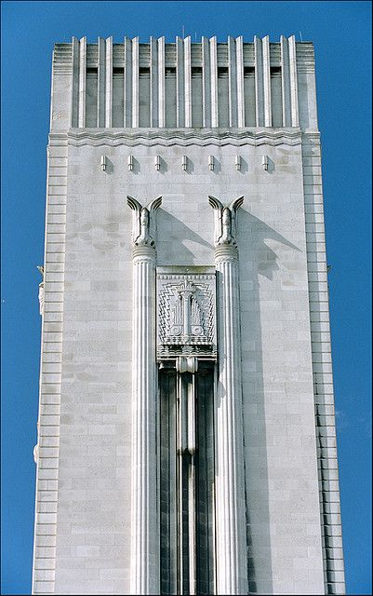

# Level: Main

## Gameplay Guidelines

1. Geometry to maximize flowing aerial gameplay
   1. Geometry in this level should primarily be structures that help a player descending to the ground get back up in the air as smoothly as possible, with as little hard edges as possible. Structures like ramps, halfpipes, or bowls suit this purpose.
   2. Geometry mid-air is allowed as long as it does not pose as an obstacle, allows the player to stand on or slide over, and/or is an adequate distance above the ground as to not block players wanting to pass underneath it.
2. Limited line of sight
   1. If a player stands in front of Team A’s goal, they should not be able to see and/or score in Team B’s goal.
   2. Players should be encouraged to move close towards a goal in order to score. Long distance shots should not be encouraged.
3. Non-angular corners and edges of the arena
   1. The arena’s border walls should not have 90° corners, but instead be rounded so players who move into this corner are not immediately stopped, but instead slide along the wall past the corner.
   2. There should not be a 90° corner where the bottom of the border wall meets the floor, but instead be rounded, so players who move towards the wall are not immediately stopped, but are instead launch up against the wall into the air.
4. Suited for all skill levels
   1. The first and primary level of our game should be suited for players of all skills levels, especially beginning players. Players should not be required to do advanced movement or have too much trouble keeping in a smooth flowing state. Both beginning and advanced players should be able to win and lose games without abusing or falling victim to abuse of the low skill ceiling.
   2. Geometry should help make catching the ball easier by influencing where the ball rolls to naturally on the ground, limiting overall verticality, changing arena size, etc.
   3. Defending is naturally more difficult than attacking, and thus the level should aim to help defenders and offer them ways to more easily block a shot, intercept the ball, take out enemy players, etc.
5. Enough space to build up speed
   1. It should not be a challenge to fully explore what the movement system has to offer. Players should have enough room to build up speed/momentum, get familiar with movement, try out new manoeuvres, and get higher scores.
   2. If a players starts moving forward from one end of the arena, they should be able to get close to top speed by the time they reach the middle of the level.

## Iterations & Process Details

First Blockout - Top Down Map

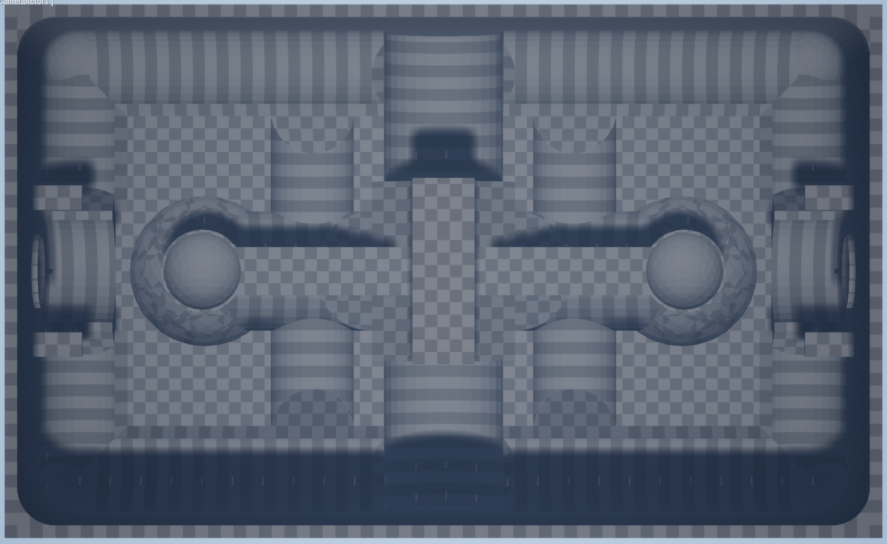

First Blockout - Perspective Screenshots

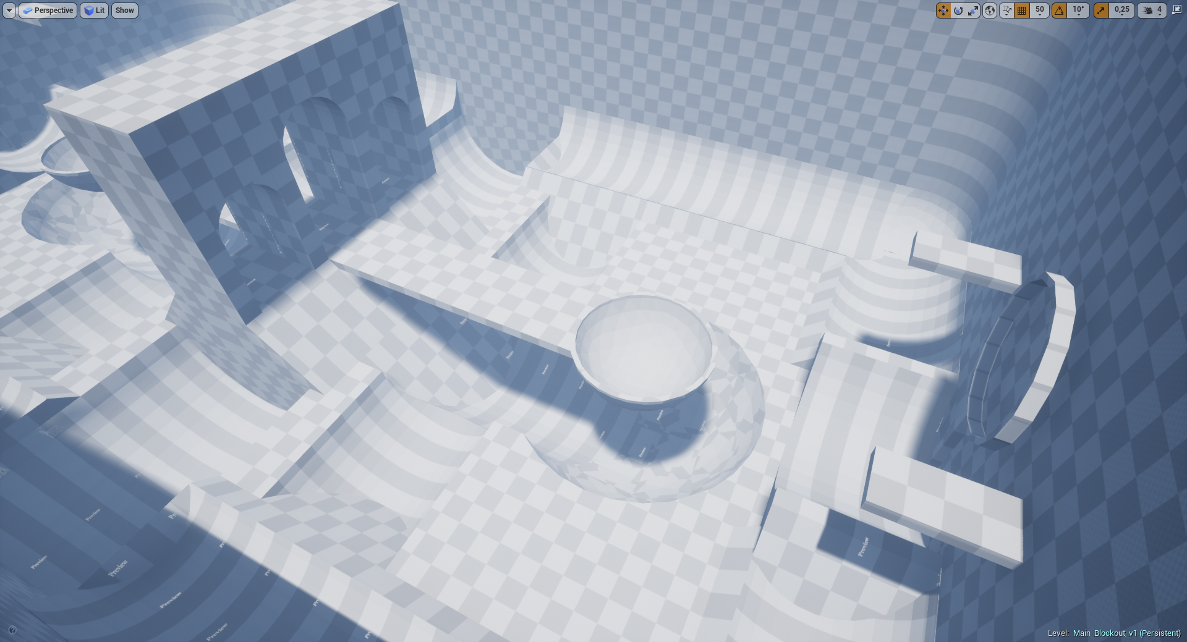

First Blockout - Process Details

In the first version of the level, I wanted to experiment with verticality and the game’s movement mechanics, and find a balance between attacking and defending.

The movement at the time was still in a rough state and I was quite unfamiliar with it, which resulted in many flow issues in this version. The big platform in the middle (that unintentionally looks like a spoon) was meant to provide attackers a way of moving to the goal very aggressively, but it turned out that the bowl at the end just broke flow massively. The bowls ended in a 90° angle which turned out to not work well with the movement system. The overall scale of the arena was too small. The ramps were also not well aligned, and there were many places where you would lose your speed if you did not land correctly.

It became obvious that the level was not only bad for player flow/navigation, but it was also too hard for new players to move around in. I wanted to make the first level of the game accessible to new players but it turned out the level looked too complex. Whether that was actually the case gameplay-wise I did not test, but the level should not scare off new players either way.

First Whitebox - Top Down Map

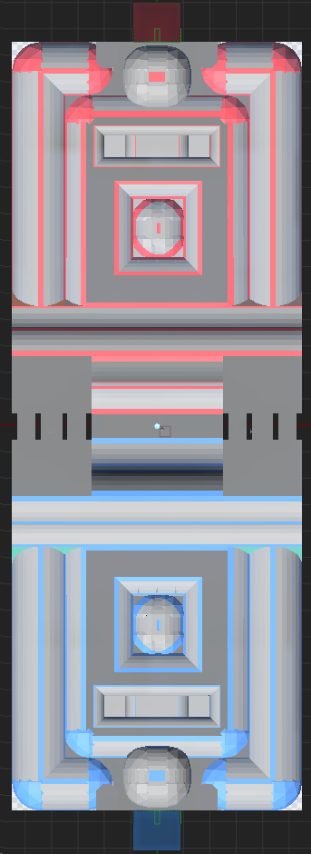

First Whitebox - Perspective Screenshots

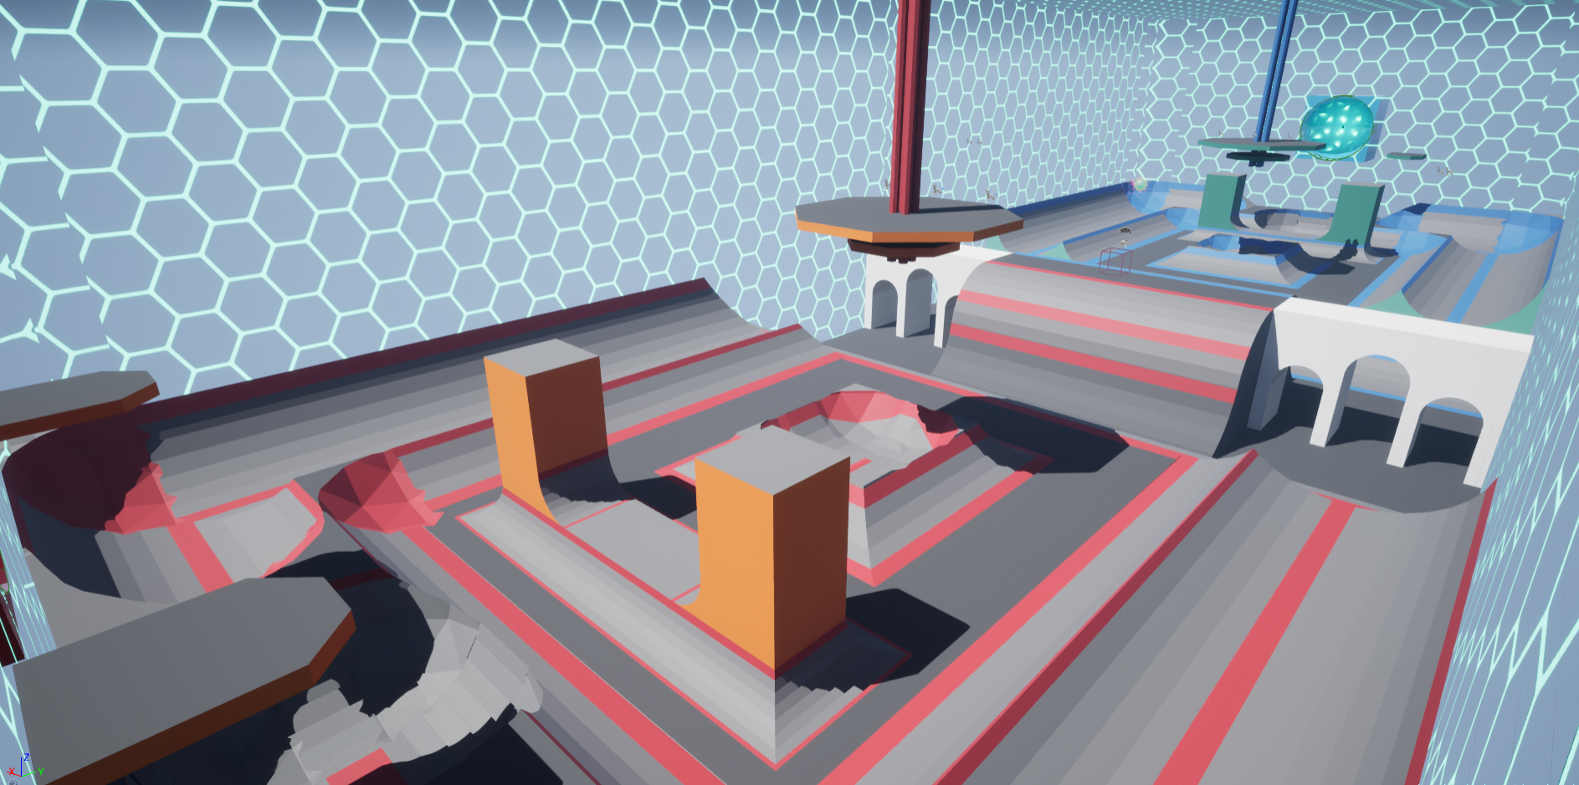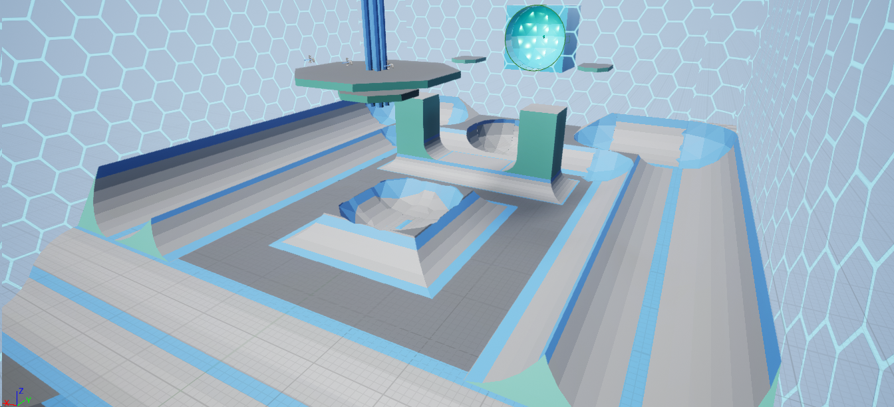

First Whitebox - Process Details

After receiving feedback on my blockout, I started building the whitebox to incorporate these improvement points and get more feedback as fast as possible.

The movement at this point had been locked down, and I was more familiar with it after testing it in the Gym Level. It showed me that the first blockout was indeed too small, and that the ramps were too narrow to properly preserve your momentum. I also realized making too many intersecting half pipes would only break flow. I limited verticality more and removed the big spoon-like construction for a more open playing field.

With this info, I set out to make the level bigger and remove some of the ramps and half-pipes, and instead make the remaining ramps wider. This resulted in a smoother flow throughout the level, and less moments where players would lose their momentum. There were some points where players would still lose their flow, such as at the big hill in the middle and the bowls on each side of the arena.

I also placed two pillars near each goal as a way of helping defenders; they could stand on top of the pillars and dash to the sides to catch an incoming ball. It turned out however that these pillars were not used like this, and that players saw no point in getting on top of them.

Another thing I noticed was that the half-pipes to the sides were encouraging a flow that would go throughout the entire level. There was little room to make 8-shape paths and thus the level felt small.

Overall, it was definitely an improvement, but I still had not found a layout that fit the type of game we’re making. Scale and flow are two things that are crucial, and that I definitely underestimated.

2nd Iteration Whitebox - Top Down Map

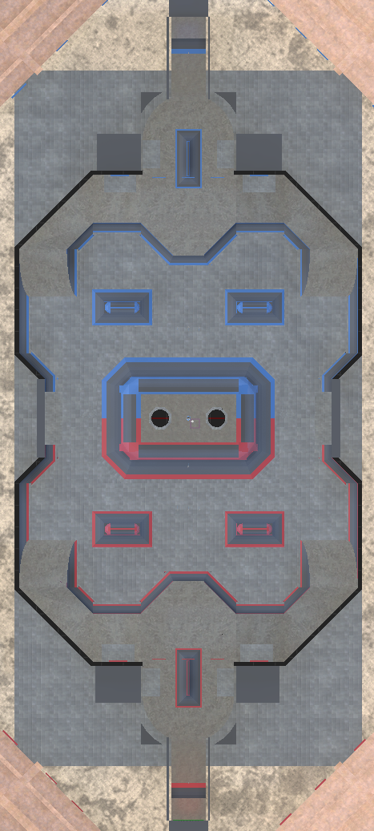

2nd Iteration Whitebox - Perspective Screenshots

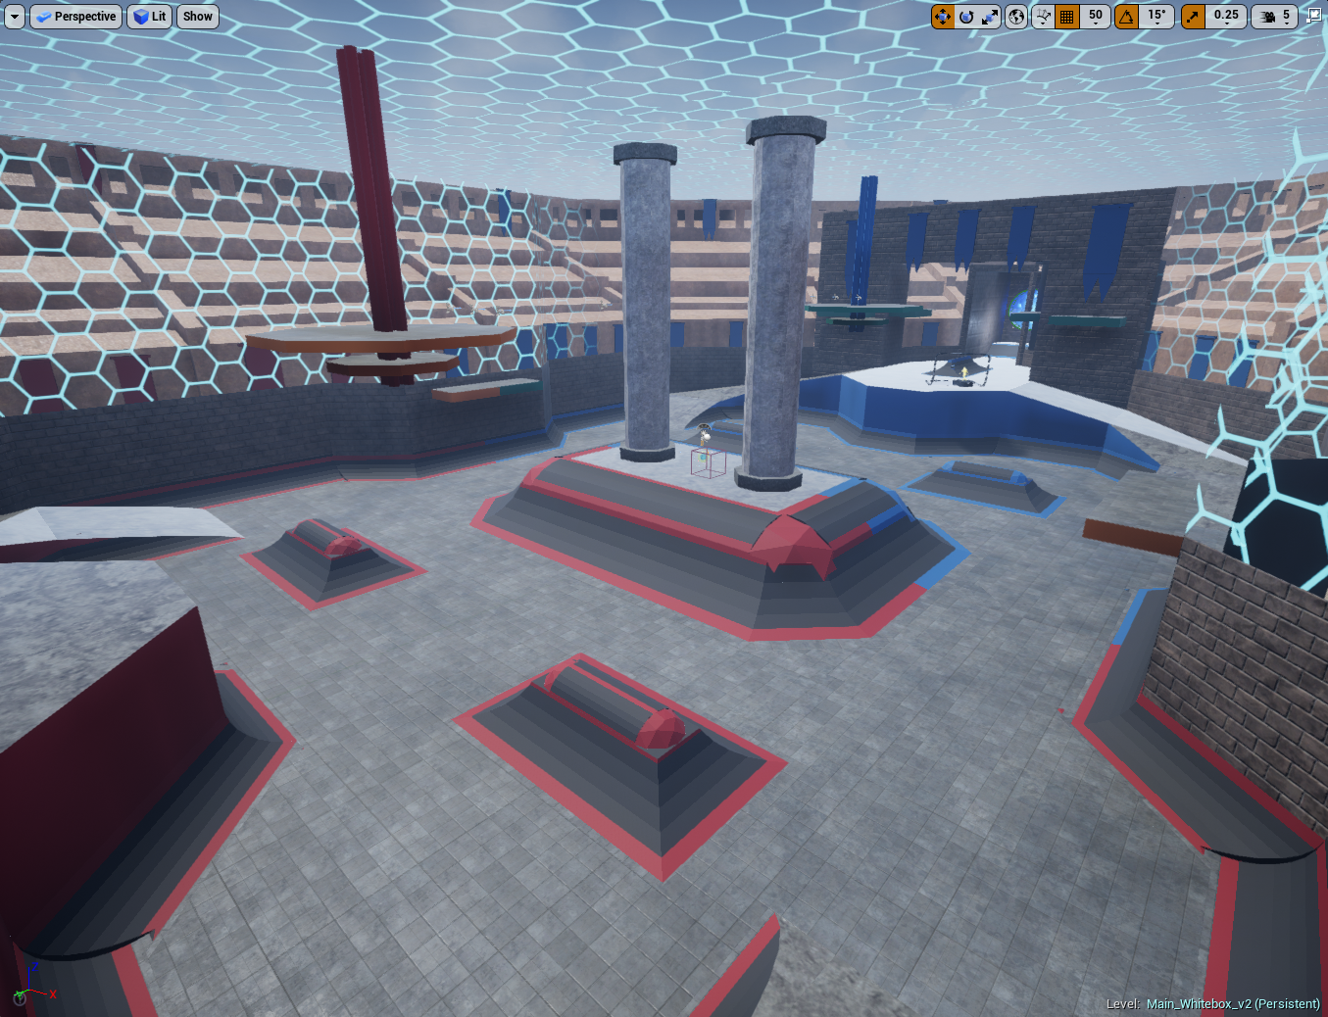

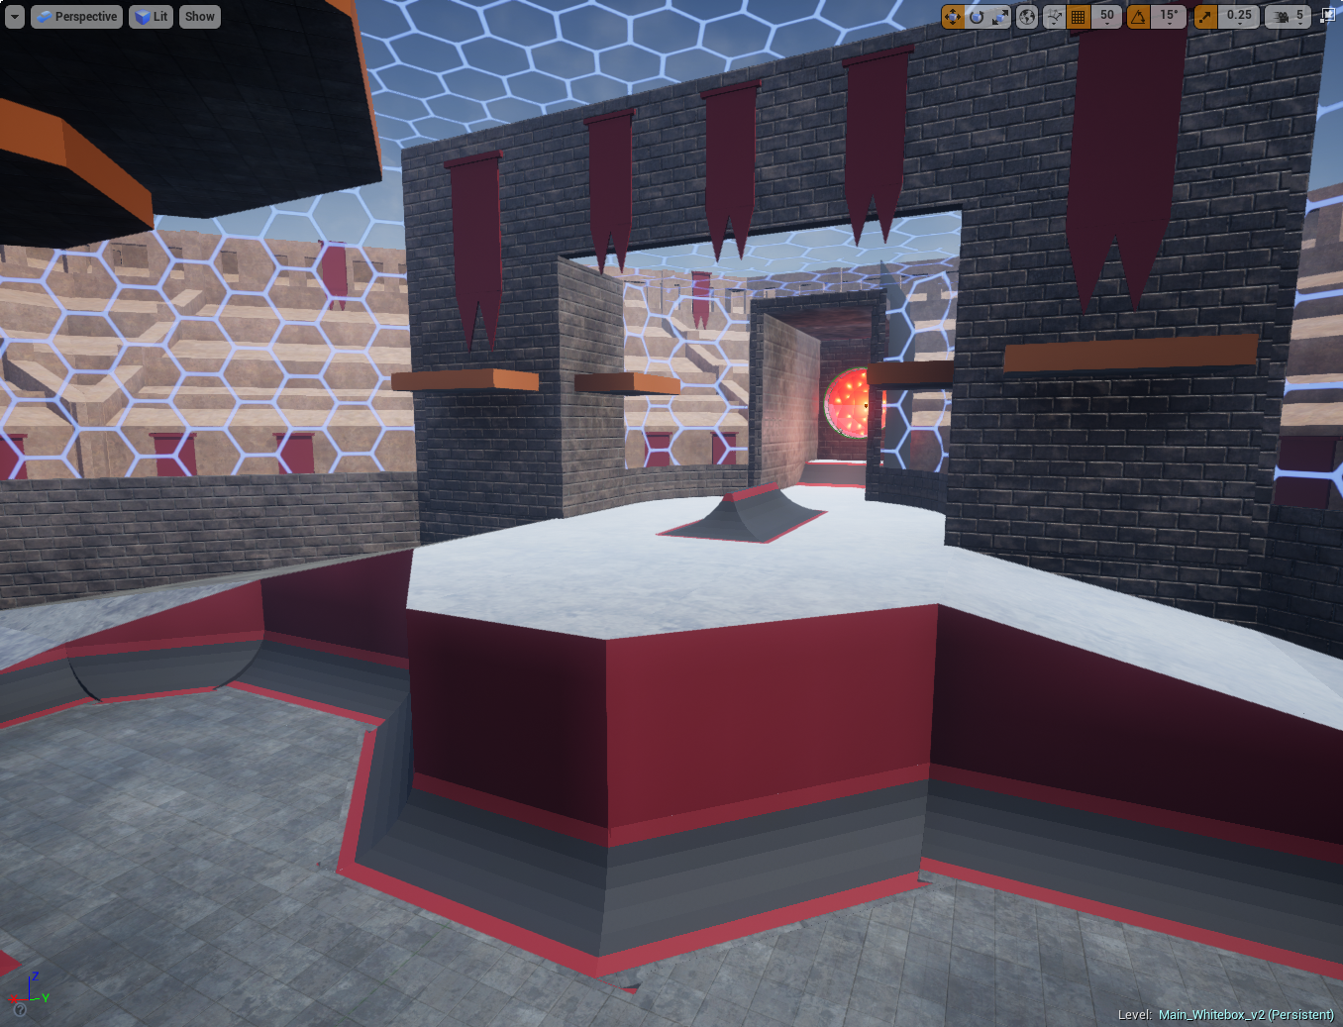

2nd Iteration Whitebox - Process Details

Again, the layout of the level has changed drastically. I wanted to experiment with arena shapes and concluded that just having a rectangular shape isn’t the best fit for our game. I made a slight adjustment to the overall shape to hopefully fix the flow issue found in the previous iteration.

First of all, I pushed in the sides of the level in the middle to encourage players to cross the level in the middle and form an 8-shaped flow throughout the centre area. This required me to adjust the middle part of the level too, which resulted in lowering the hill in the middle and removing the half pipes next to it, including the arch structures. By limiting this verticality in this area, players would need to steer themselves towards ramps a bit more but it also improved general flow through this area. The half pipes in the previous iteration would stop players if they didn’t land correctly, and this issue is now fixed.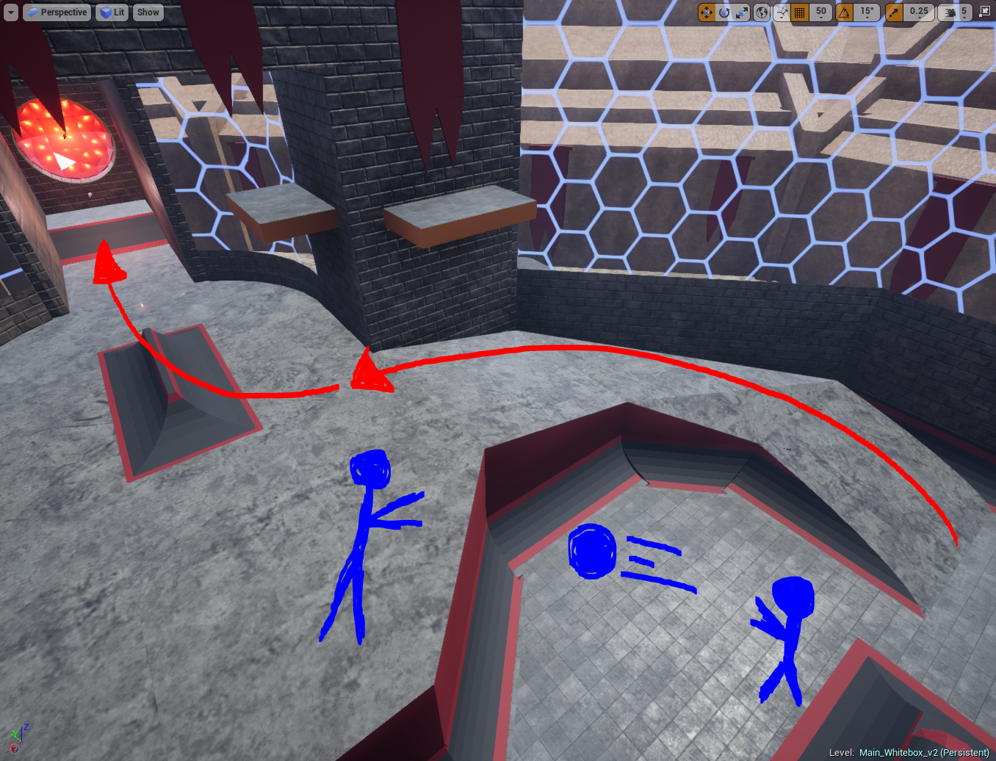

Secondly, I raised both ends of the level to create a high ground for defenders. The difference in verticality would also encourage passing more, and created a different flow through the level. It created several new paths towards the goal, keeping in mind the dynamic between attacking and defending more than before.

The amount of ramps have also been decreased to the amount where there are still enough to get up in the air easily, but not too many that it breaks flow when you land in the wrong spot.

So far, playtesting has shown an immediate improvement in flow through the level, and gameplay has benefited from these changes too. Attacking and defending is much more dynamic than it was before. Readability has also improved massively, which in combination with the simplified layout helped players focus more on the game and less on the level.

Final Iteration Whitebox - Top Down Map

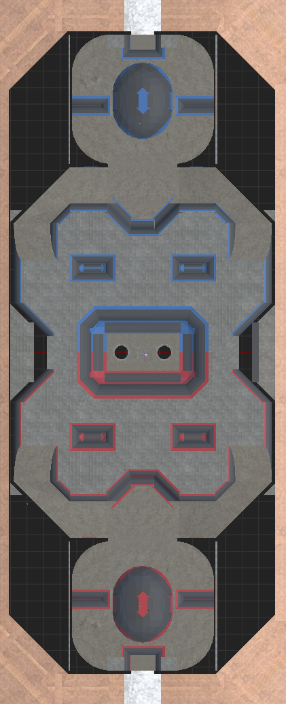

Final Iteration Whitebox - Perspective Screenshots

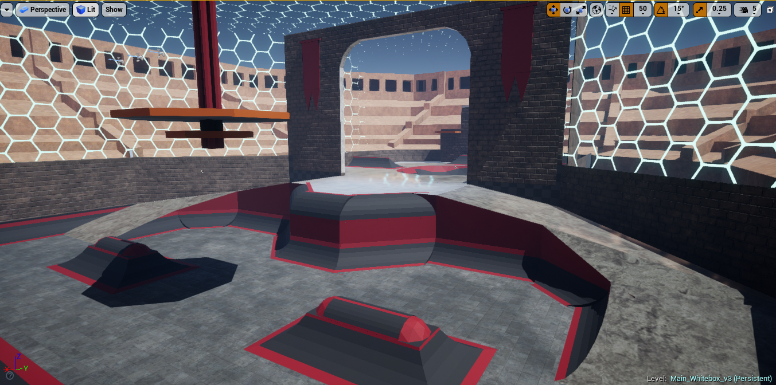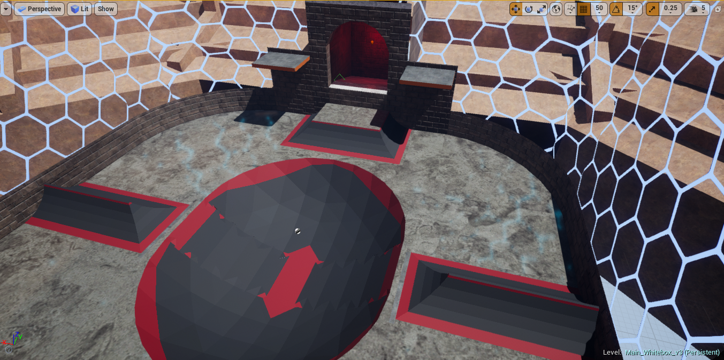

Final Iteration Whitebox - Process Details

Not much has changed compared to last iteration, except for the goal area. The chokepoint was too impactful on gameplay, and sometimes even counteracted its purpose and made attacking easier instead of defending.

The gate before the goal is still there, but the narrow hallway is replaced with a larger open space. It features a large bowl in the centre, with two ramps to the sides. The player is guided towards these ramps, making two main routes towards the goal for attackers (red arrows). This makes predicting attacker paths easier for defenders, but also creates another 8-shaped path. A small ramp is placed in front of the goal to leap up to the goal, or for defenders to stand on and block incoming balls. They can also use the ramp to get up on the platforms next to the goal, which allows them to catch higher balls or shoot at incoming attackers (green arrows).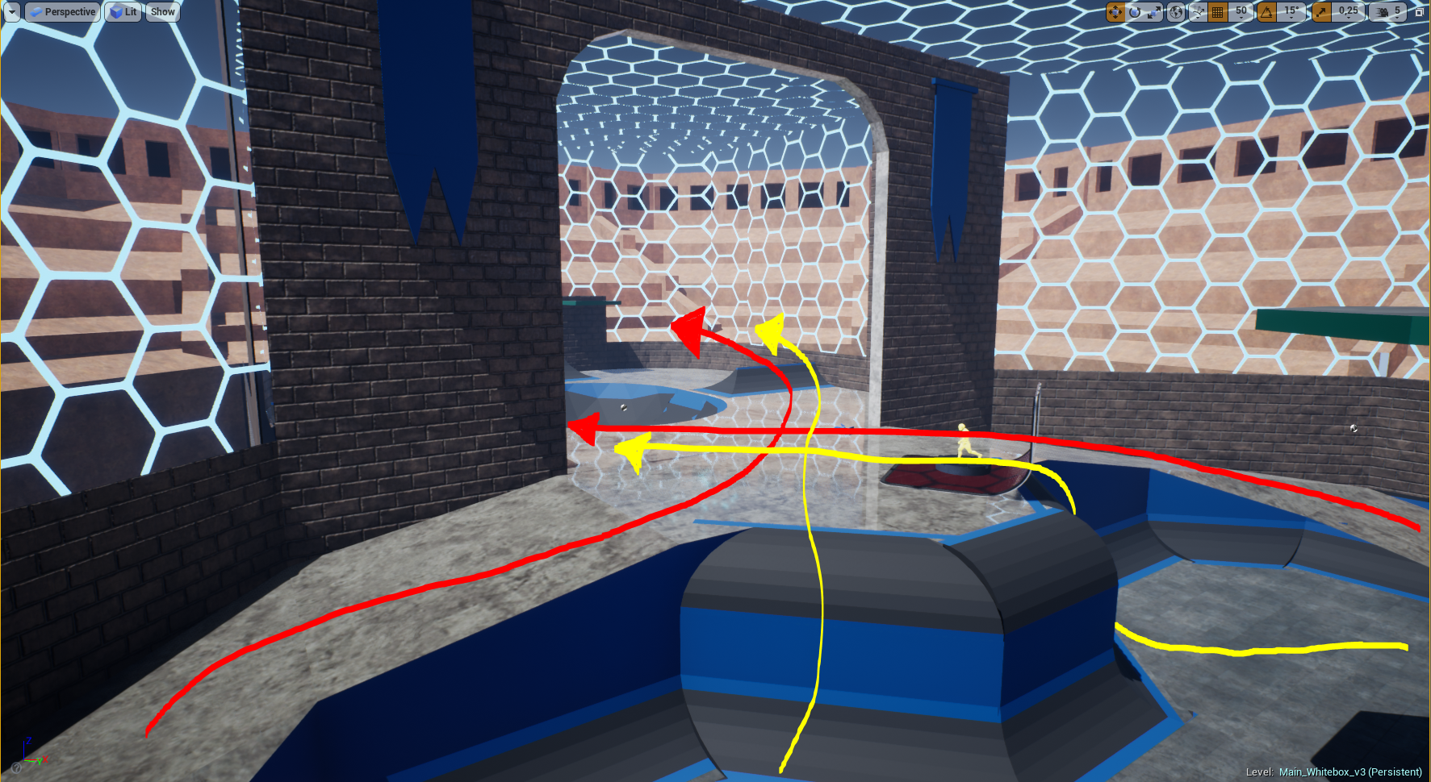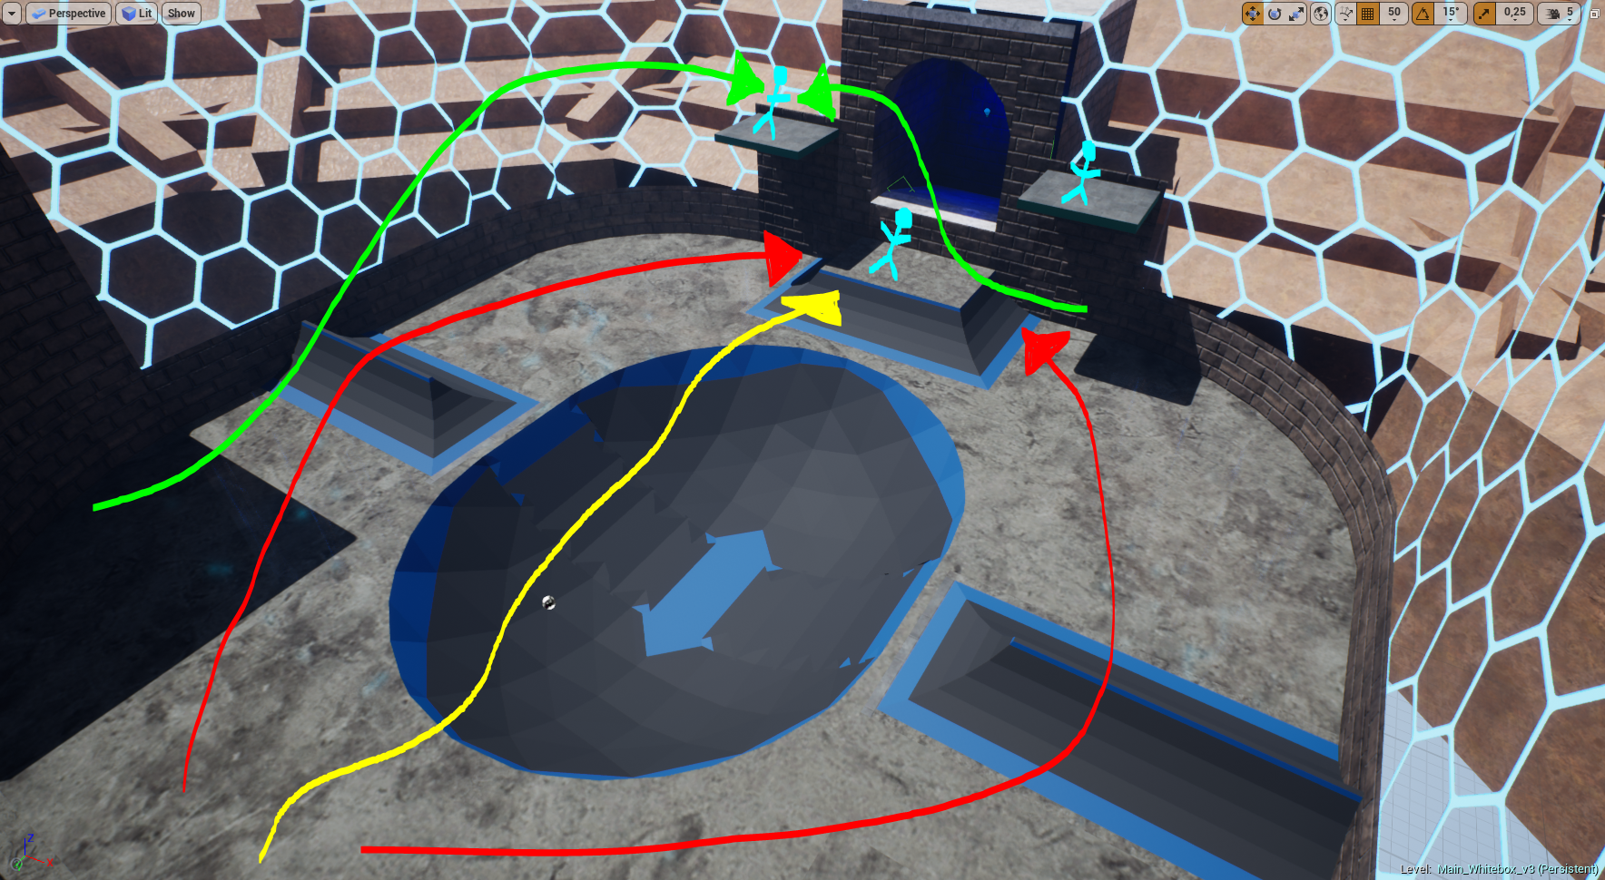

Playtests have shown this is a major improvement to the dynamic attacking/defending aspect of our game. There have been several moments where players were able to catch a ball moments before it hit the goal, which confirms that attacking and defending is improving.